Networks

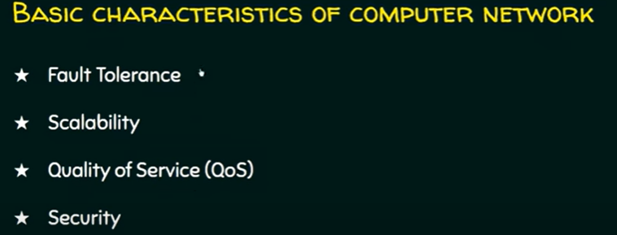

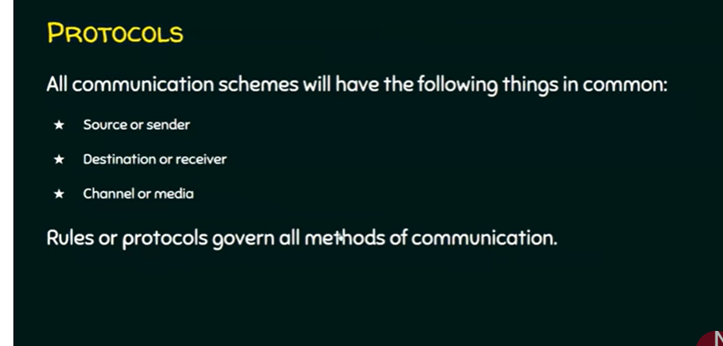

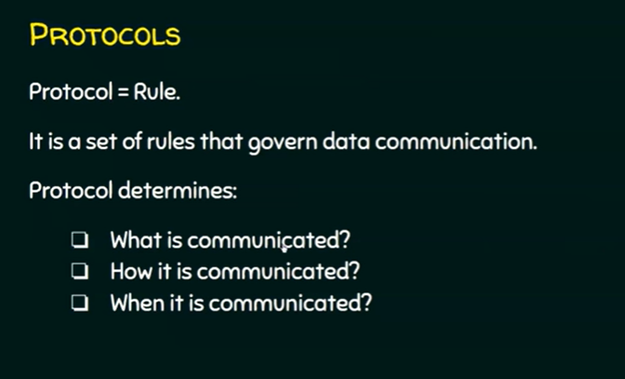

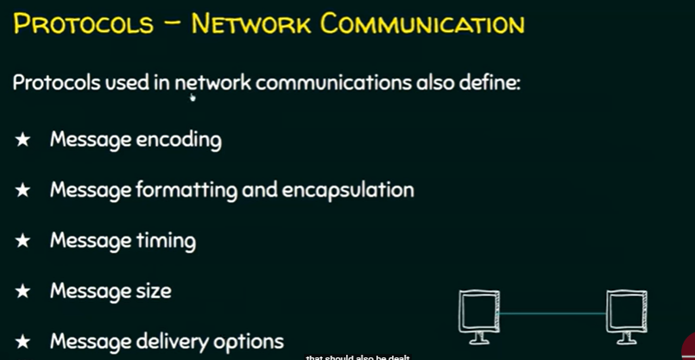

Encode means to change something into a programming code. For instance, **changing a letter into the binary code for that letter** or changing an analog sound into a digital file.

* Every computer in the network is uniquely identified by IP addresses.

COMPONENTS OF COMPUTER NETWORK:

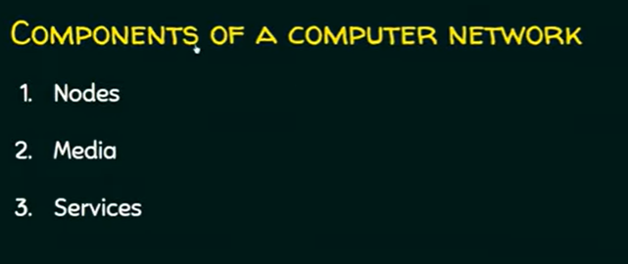

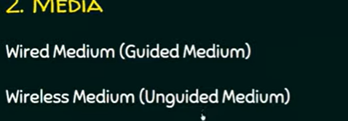

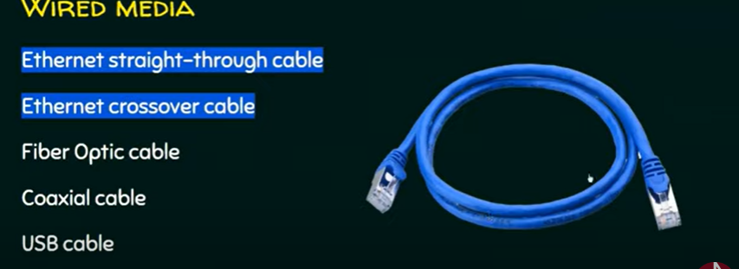



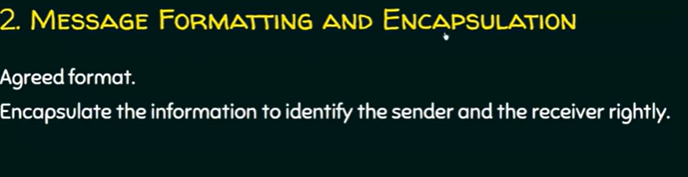

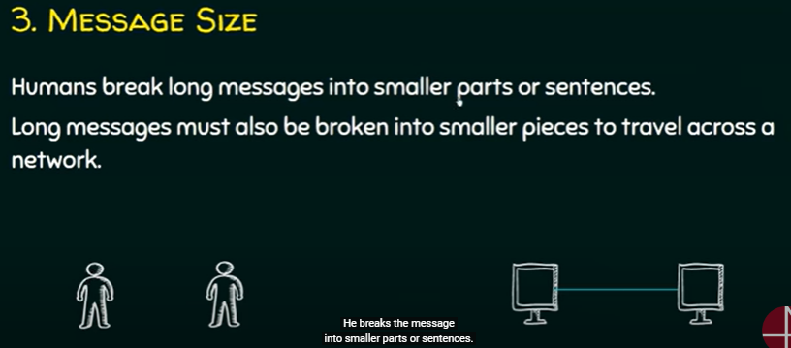

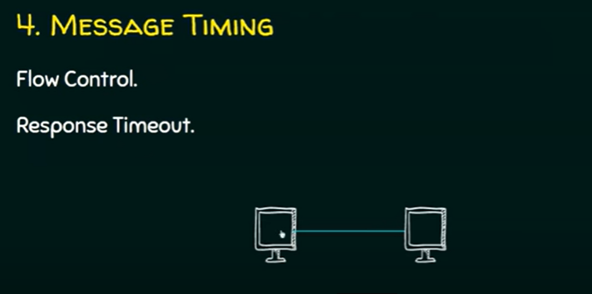

NETWORK HARDWARE:

3.TYPES:

1.UNICAST

2.MULTICAST

3.BROAD CAST

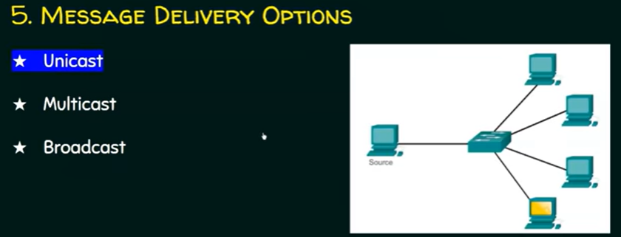

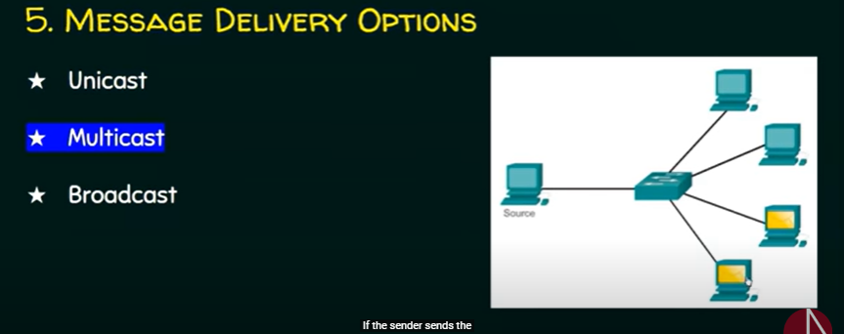

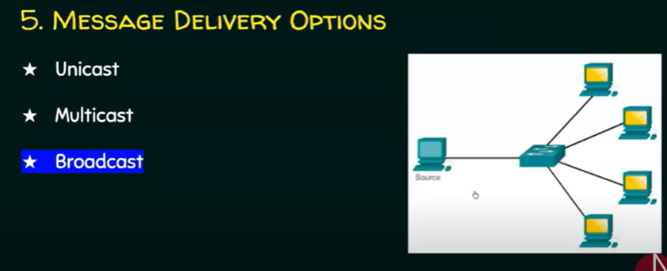

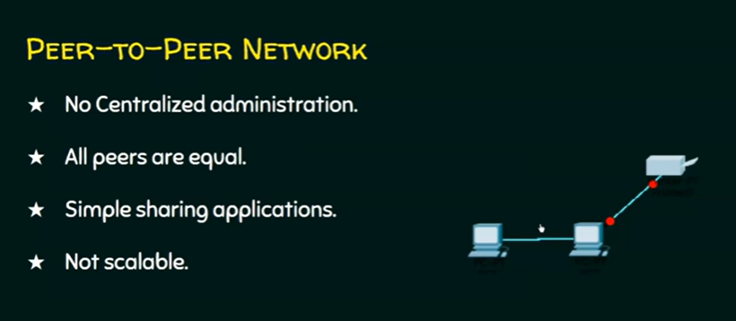

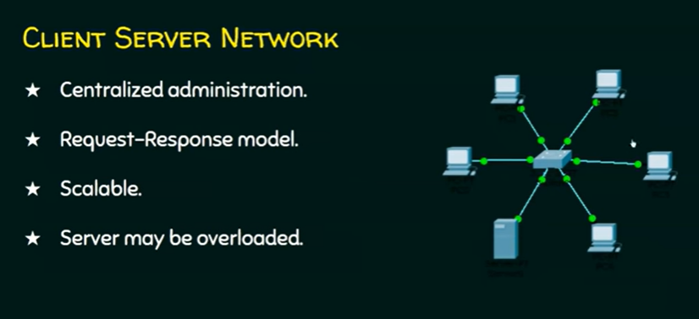

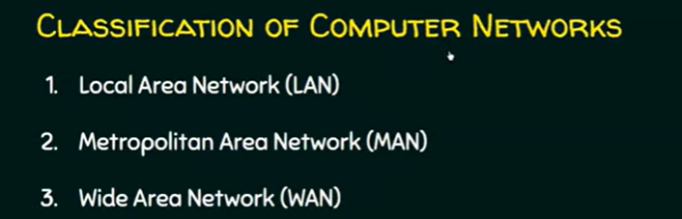

1.

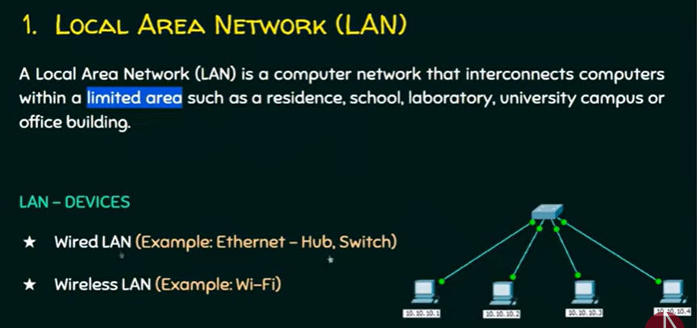

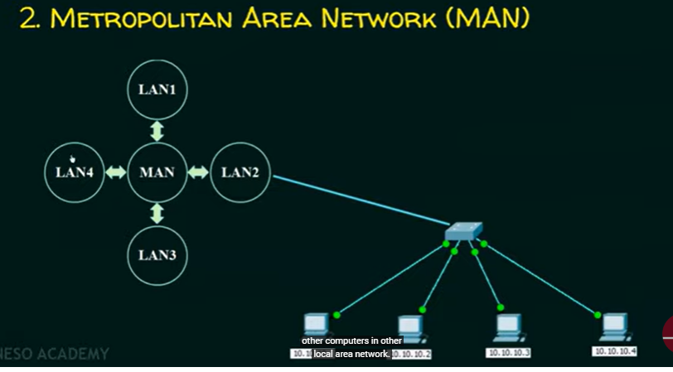

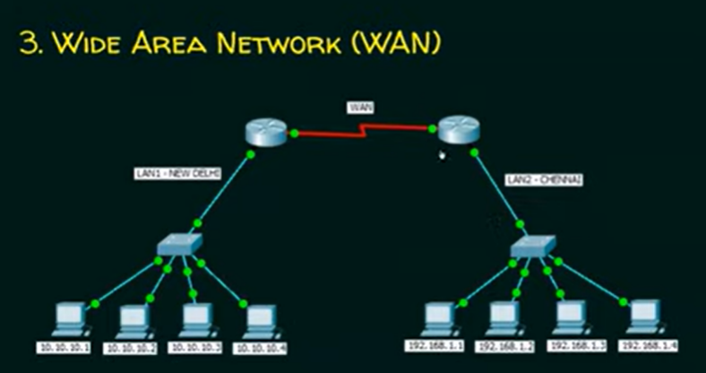

* Communication blw 2 lans blw the 2 places in a country

Network topologies:

**Topologies means arrangement of nodes in the network so that we can establish communication blw nodes.**

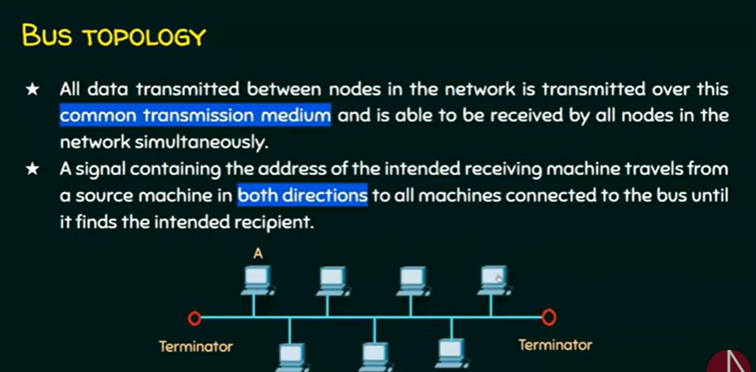

**A bottleneck, in a communications context, is a point in the enterprise where the flow of data is impaired or stopped entirely. Effectively, a bottleneck results when there is not enough data handling capacity to accommodate the current volume of traffic.**

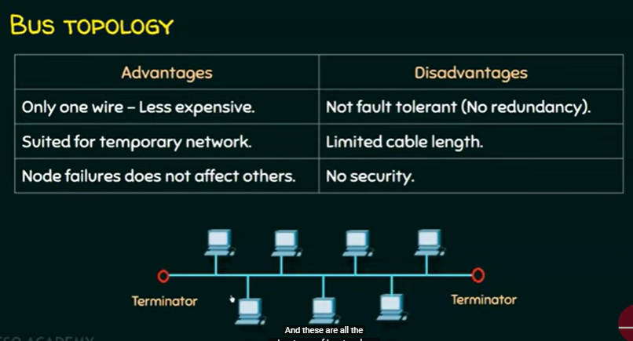

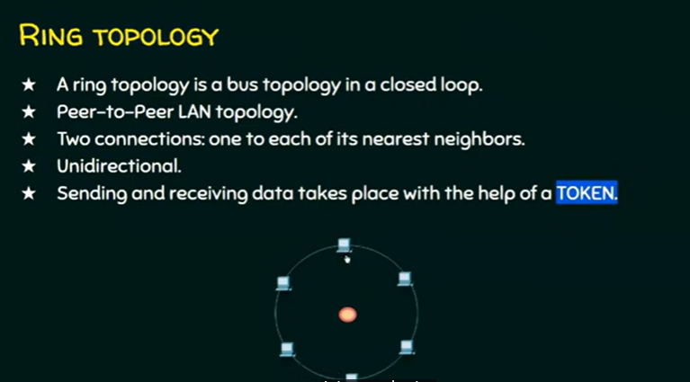

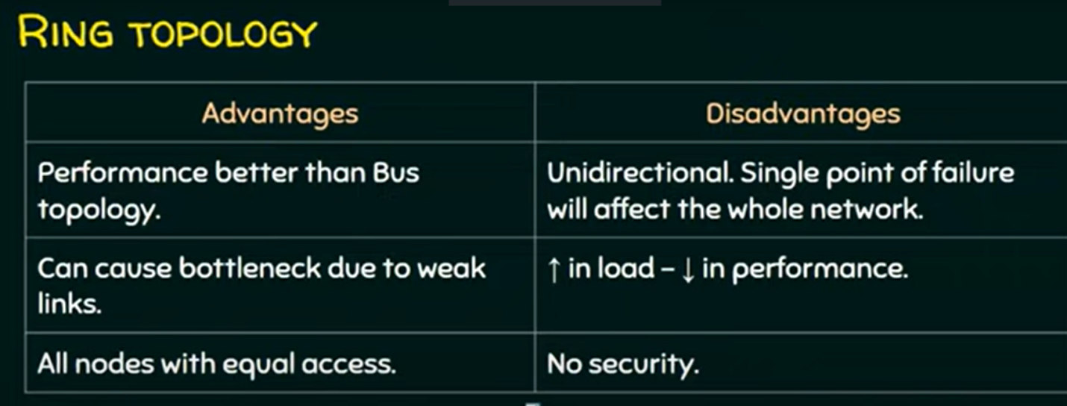

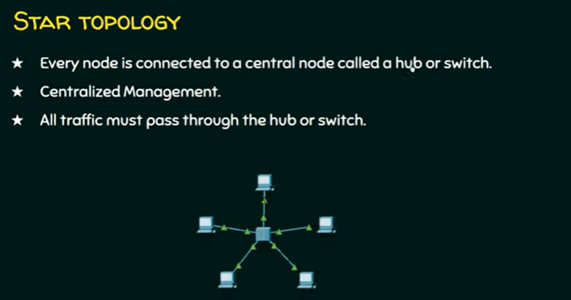

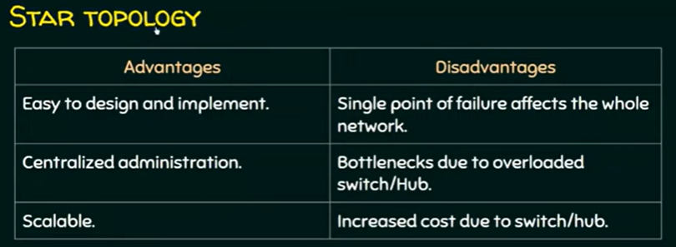

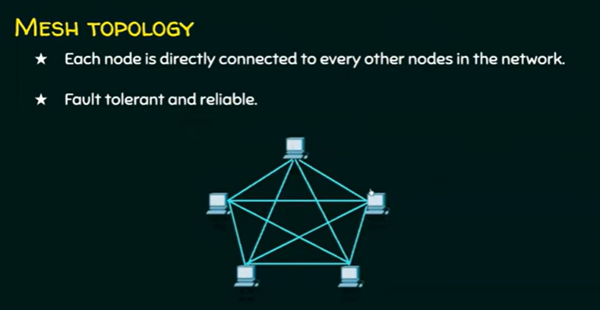

SWITCHING :

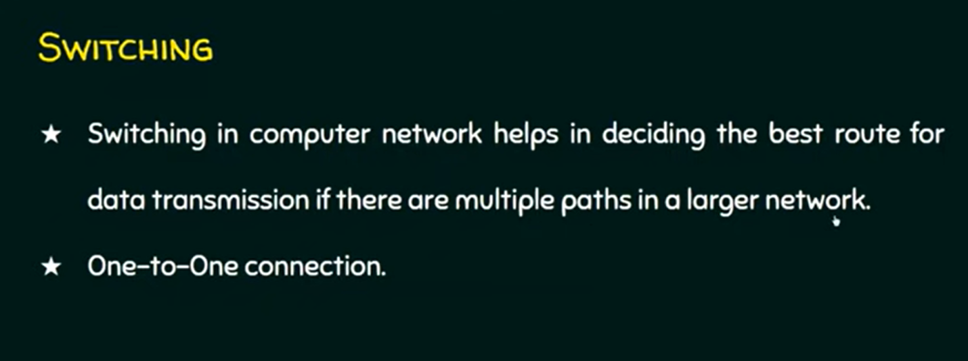

Example : in internet there are multiple paths blw source and destination

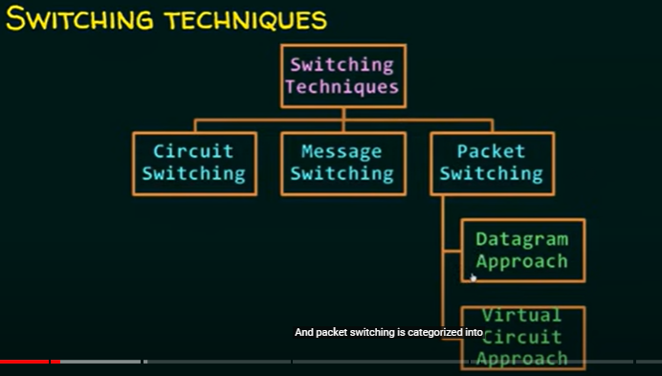

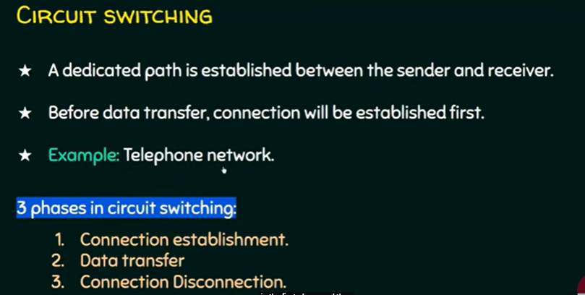

**Example phone call**

**1. Enter phone num and connection is established**

**2. Data transferring and communicating each other**

**3. Disconnected**

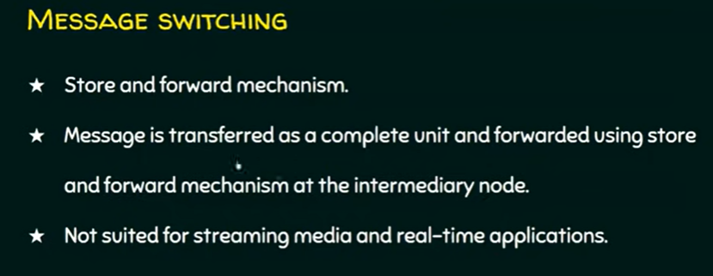

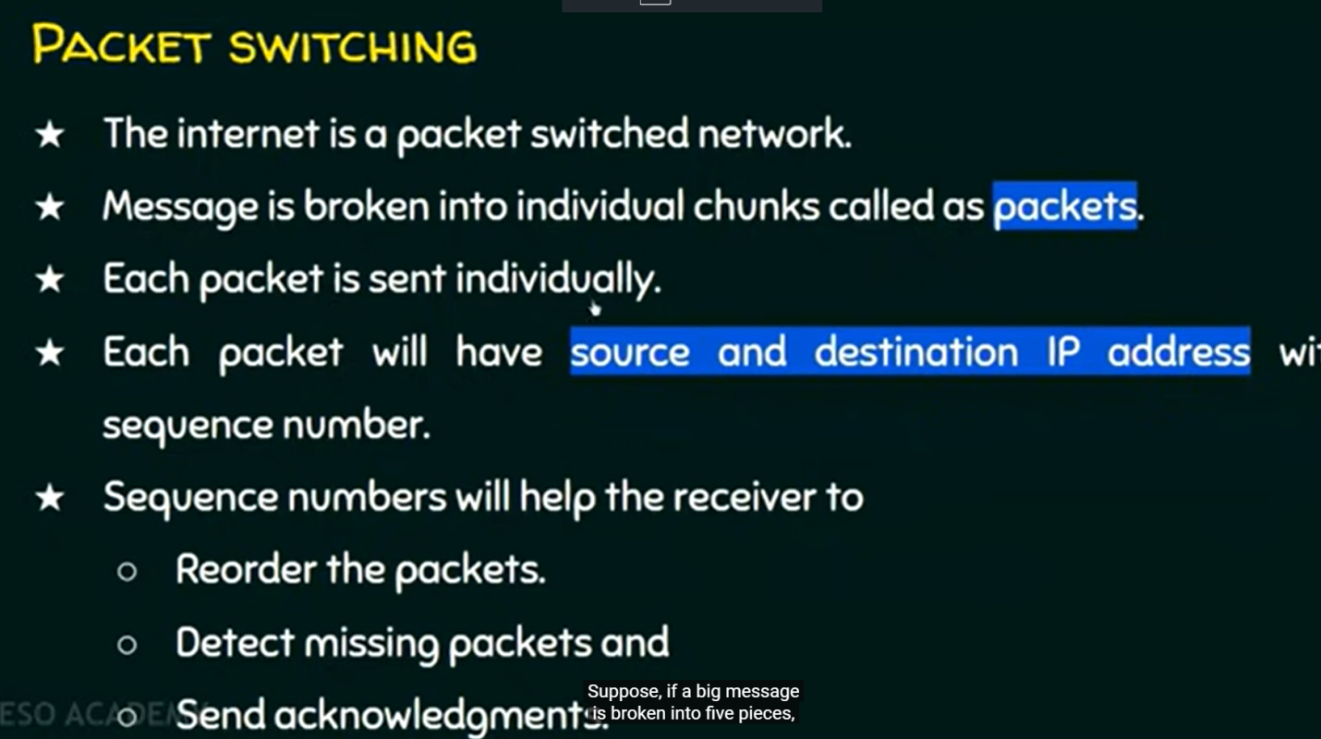

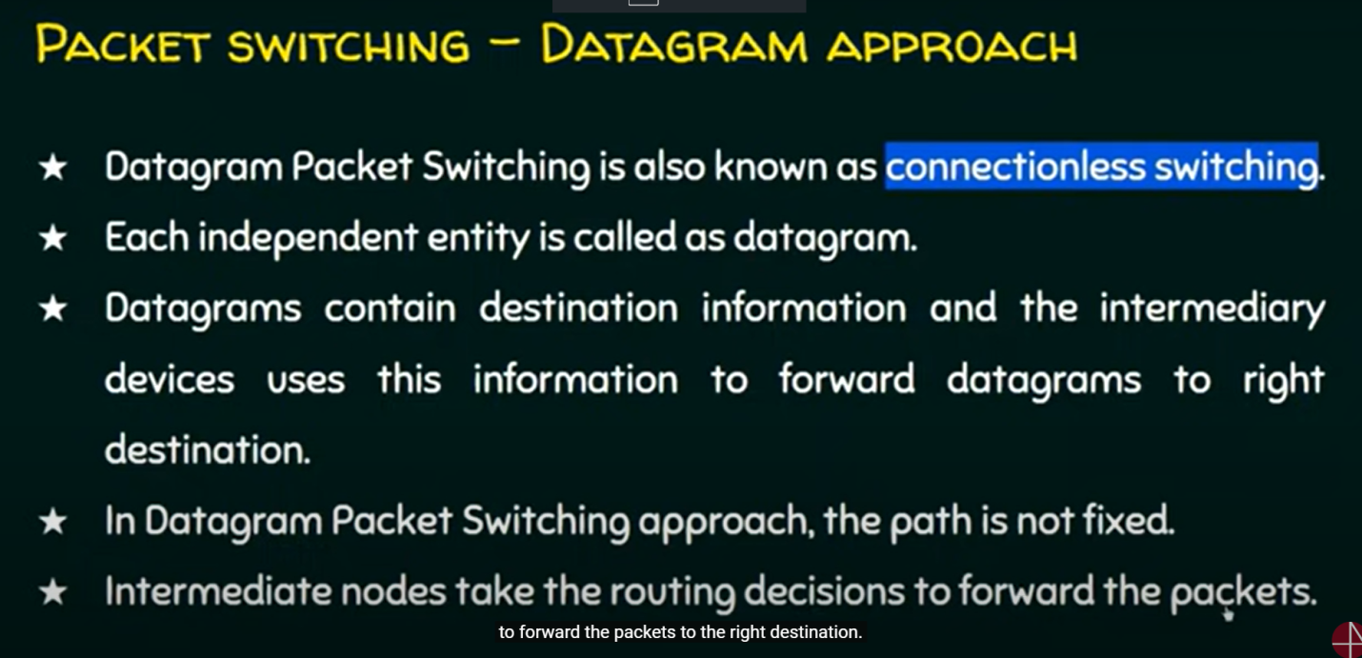

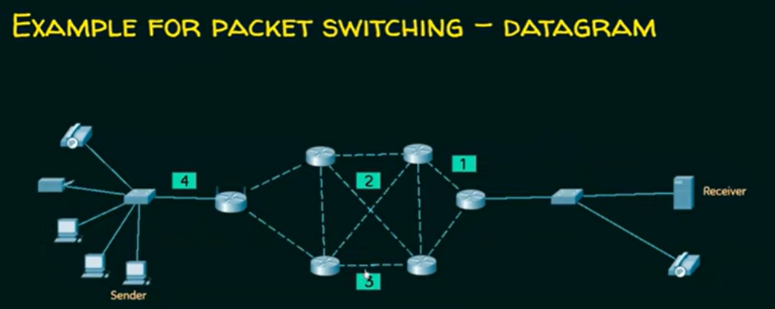

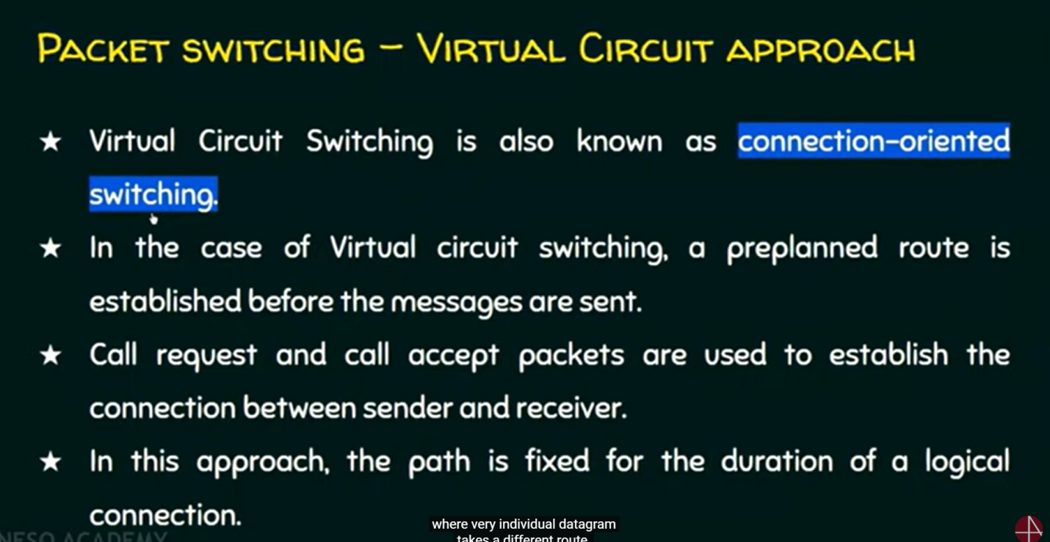

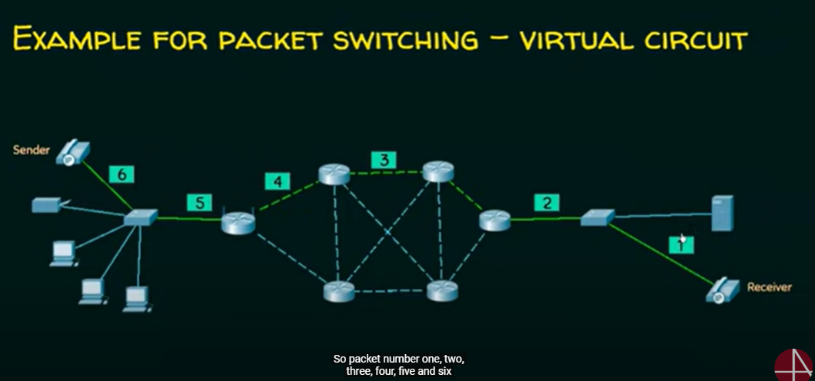

Analog and digital signals are the types of signals carrying information. The major difference between both signals is that the analog signals have continuous electrical signals, while digital signals have non-continuous electrical signals. The difference between analog and digital signal can be observed with the examples of [different types of waves](https://byjus.com/physics/waves/).

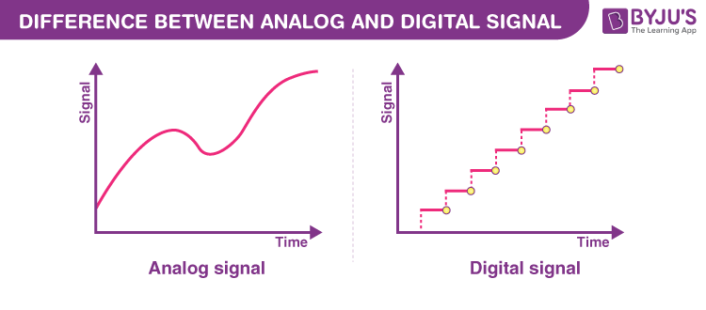

|  |
| --- |
| **Table of Contents:**   * [What are Analog Signals?](https://byjus.com/#what-are-analog-signals) * [What are Digital Signals?](https://byjus.com/#what-are-digital-signals) * [Difference Between Analog and Digital Signal](https://byjus.com/#difference-between-analog-and-digital-signal) * [Frequently Asked Questions – FAQs](https://byjus.com/#frequently-asked-questions-faqs) |

What are Analog Signals?

Analog signals were used in many systems to produce signals to carry information. These signals are continuous in both values and time. The use of analog signals has declined with the arrival of digital signals. In short, to understand analog signals –  all signals that are natural or come naturally are analog signals.

What are Digital Signals?

Unlike analog signals, digital signals are not continuous, but signals are discrete in value and time. These signals are represented by binary numbers and consist of different voltage values.

Difference between Analog and Digital Signals

To summarise, we have given the various differences between analog signal and digital signal in a tabular form below.  
Both these signals are used in [electronic communication system](https://byjus.com/physics/terms-used-electronic-communication-systems/) to transfer information from one place to another.

|  |  |
| --- | --- |
| **Difference Between Analog And Digital Signal** | |
| **Analog Signals** | **Digital Signals** |
| Continuous signals | Discrete signals |
| Represented by sine waves | Represented by square waves |
| Human voice, natural sound, analog electronic devices are a few examples | Computers, optical drives, and other electronic devices |
| Continuous range of values | Discontinuous values |
| Records sound waves as they are | Converts into a binary waveform |
| Only used in analog devices | Suited for digital electronics like computers, mobiles and more |

Refer: <https://us.hitrontech.com/learn/the-difference-between-a-modem-and-a-router/>

Layering:

